theHive (performance tool for IBM I from SE)
https://thehive.midrange.ca/
Maqsood.ahmed@staples.ca
Aliyaan@2013

748505 teamcode

Maqsood.Ahmed@sptales.ca
0413=rhstAM&/Aliyaan@2013
User id = AhmMa005
Emp# 3075853

Network : AhmMa005
Y7F#ZOgwRuXE

Email2Phone
Use this URL to goto EmailtoPhone site https://user.email2phone.net/client/#/authentication/signin

login with id Staples.SupportCell
Pwd is Staples786

As/400
Mahmed
welcome1

- System : MAR4DEV1
- User ID: MAHMED\
- Password: welcome2

- System : BUSDEP
- User ID: MAHMED
- Password: welcome1
I created the following Security Officer Profile on our Development box (MAR4DEV1).
- User ID: SECMAQSOOD
- Password: welcome1

ServiceExpress
Customer Service Portal - Customer Support
Maqsood.ahmed@staples.ca
Aliyaan2013@2013

https://customer.precisely.com/s/
Maqsood.ahmed@staples.ca
Aliyaan@2013

http://10.19.240.77:2001/DCM
secmaqsood
welcome1

security password Staples786

microfocus
malikmaqsood/ Aliyaan@2013

IBM service – id
Maqsood.ahmed@staples.ca
Aliyeaan@2014

Freshce access X-analyisi
https://www.myfreschesolutions.com/kb?kbnum=16204
Maqsood.ahmed@staples.ca
Aliyaan@2013

implementer
http://www.ptc.com/support/
Maqsood.ahmed@staples.ca
Aliyaan@2013

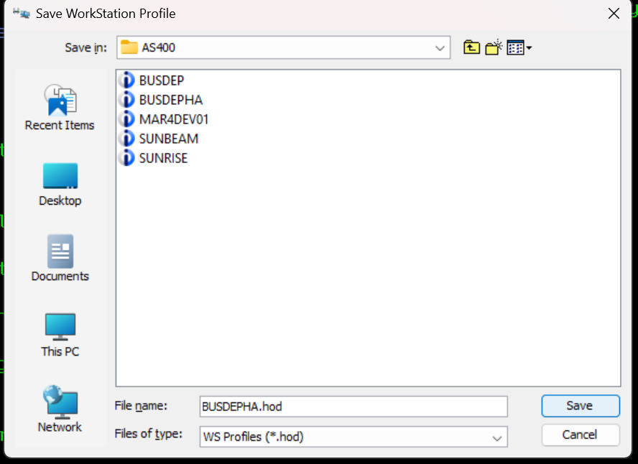
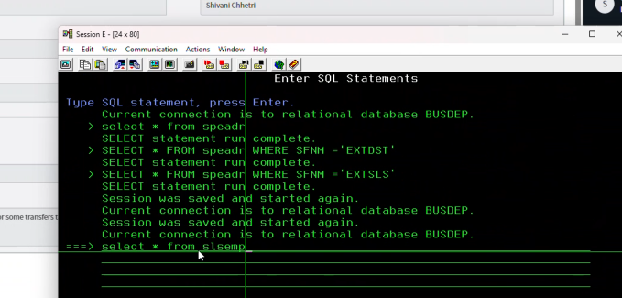

How to define work-station-id
change the default workstation to another one.
'DSP' + department ID + User Initial + 'S' + any number from 1 to 9.

